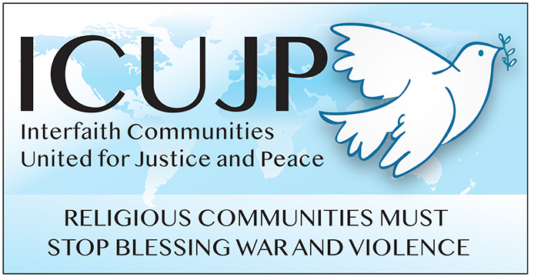
www.icujp.org • www.facebook.com/icujp

ICUJP Friday Forum Agenda

The Constitution and Our Challenges Today
August 5th, 2022 | 7:30–9:30 am PT
Online via Zoom: https://us02web.zoom.us/j/85125256537
Call in: +1 669 900 6833 US
Meeting ID: 851 2525 6537 PASSCODE: 817560
Facilitator: David Clennon | Zoom host: Dave Clennon

7:30–7:35 Log in and socializing
7:35–7:45 Welcome and brief introductions
7:45–7:50 Reflection: What Matters to Me – Stephen Rohde

7:50–9:15 Program and Q&A: In 2010, Heart of LA partnered with the Los Angeles Philharmonic to launch a youth orchestra program.The Youth Orchestra LA (YOLA) at Heart of Los Angeles (HOLA) is the second site of Gustavo Dudamel’s signature program and features several youth orchestras. HOLA also provides a structured Music Studios program, including jazz and rock bands and now also a premiere Intergenerational Orchestra, Choir and Big Band Programs!!
9:15–9:20 Announcements
9:20-9:30 Closing circle and prayer
Reminder: During this time of staying home, please donate to Immanuel Presbyterian's Food Distribution Center. The need is more critical than ever! Donate here: https://bit.ly/IPCpantry
________________

SPECIAL EVENTS
SEP 11 – Pursuing Justice and Peace ICUJP 2022 George F. Regas Courageous Peacemaker (Virtual Awards Presentation)
ICUJP CALENDAR

ICUJP Board of Directors
Louis Chase • David Clennon • Grace Dyrness • Ed Fisher • Stephen Fiske • John Forney • Jasmine Hailey Maggie Hutchinson • Rosemary Leibowitz • Carolfrances Likins • Rita Lowenthal (1927-2021)
Anthony Manousos • Michael Novick • Rubi Omar • Fr. Chris Ponnet • George Regas (1930-2021)
Steve Rohde • Fidel Sanchez • Susan Stouffer • Veda Veach • Phil Way • Morgan Duff Tucker (Director of Communications)

