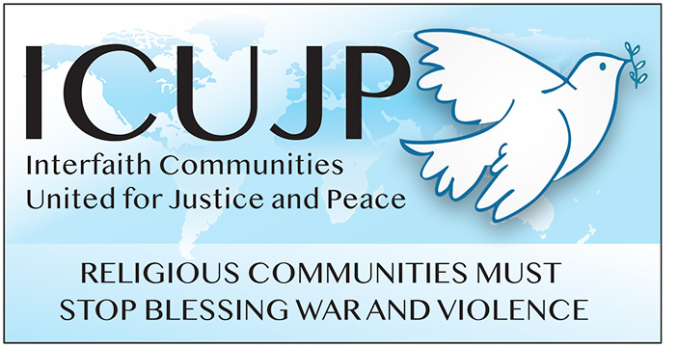
www.icujp.org • www.facebook.com/icujp

ICUJP Friday Forum Agenda

Non-Violence Themes of Pope Francis and
Artist John August Swanson (Sept 23 1st Anniversary)

September 23, 2022 | 7:30–9:30 am PT
Online via Zoom: https://us02web.zoom.us/j/87396859483Call in: +1 669 900 6833 US
Meeting ID: 873 9685 9483 PASSCODE: 483142
Facilitator: Carolfrances Likins | Zoom host: Rick Banales
7:30–7:35 Log in and socializing
7:35–7:45 Welcome and brief introductions
7:45–7:50 Reflection: What Matters to Me – Michael Novick

7:50–9:15 Program and Q&A

9:20-9:30 Closing circle and prayer
Reminder: During this time of staying home, please donate to Immanuel Presbyterian's Food Distribution Center. The need is more critical than ever! Donate here: https://bit.ly/IPCpantry
9:35 End Systemic Racism
________________

FRIDAY FORUMS
ICUJP CALENDAR
Sep 30th - John Quigley - Complicated Issues Around the War in Ukraine

ICUJP Board of Directors
Louis Chase • David Clennon • Grace Dyrness • Ed Fisher • Stephen Fiske • John Forney • Jasmine Hailey Maggie Hutchinson • Rosemary Leibowitz • Carolfrances Likins • Rita Lowenthal (1927-2021)
Anthony Manousos • Michael Novick • Rubi Omar • Fr. Chris Ponnet • George Regas (1930-2021)
Steve Rohde • Fidel Sanchez • Susan Stouffer • Veda Veach • Phil Way • Morgan Duff Tucker (Director of Communications)

