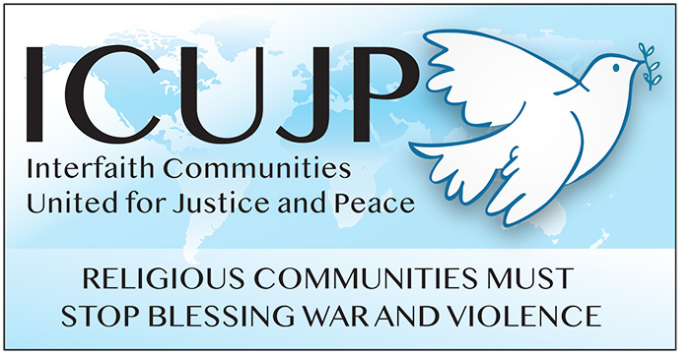
www.icujp.org • www.facebook.com/icujp

ICUJP Friday Forum Agenda

Crimea: Key to Ending War in Ukraine - Opinio Juris
September 30, 2022 | 7:30–9:30 am PT
Online via Zoom: https://us02web.zoom.us/j/81592778508
Call in: +1 669 900 6833 US
Meeting ID: 815 9277 8508 PASSCODE: 368955
Facilitator: Rubi Omar | Zoom host: Michael Novick

7:30–7:35 Log in and socializing
7:35–7:45 Welcome and brief introductions
7:45–7:50 Reflection: What Matters to Me – Rick Banales

7:50–9:15 Program and Q&A: John Quigley was appointed in 1994 by the Organization for Security and Cooperation in Europe to go to Ukraine to examine the situation in Crimea and to make recommendations to avert conflict there. He engaged in shuttle diplomacy over the following year. Based on this experience, he will discuss how he sees possibilities for ending the war in Ukraine.

9:15–9:20 Announcements
9:20-9:30 Closing circle and prayer
Reminder: During this time of staying home, please donate to Immanuel Presbyterian's Food Distribution Center. The need is more critical than ever! Donate here: https://bit.ly/IPCpantry
________________

FRIDAY FORUMS
OCT 7: Kent Wong - UCLA Labor Center

ICUJP Board of Directors
Louis Chase • David Clennon • Grace Dyrness • Ed Fisher • Stephen Fiske • John Forney • Jasmine Hailey Maggie Hutchinson • Rosemary Leibowitz • Carolfrances Likins • Rita Lowenthal (1927-2021)
Anthony Manousos • Michael Novick • Rubi Omar • Fr. Chris Ponnet • George Regas (1930-2021)
Steve Rohde • Fidel Sanchez • Susan Stouffer • Veda Veach • Phil Way • Morgan Duff Tucker (Director of Communications)

