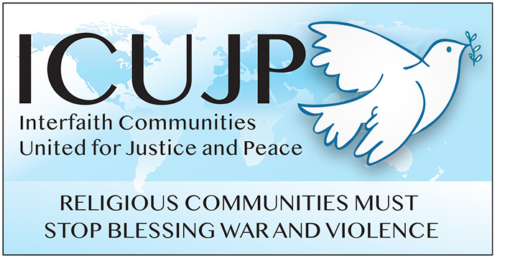
www.icujp.org • www.facebook.com/icujp

ICUJP Friday Forum Agenda

April 2, 2021 | 7:30–9:30 am PT
Online via Zoom: https://us02web.zoom.us/j/85971215958
Call in: +1 (669) 900-6833
Meeting ID: 859 7121 5958 PASSCODE: 533683
Facilitator: Steve Rohde | Zoom host: Michael Novick
7:30 Socializing (15 min)
7:45 Welcome and introductions (5 min)
7:50 Reflection: What Matters to Me (5 min) – M. Theresa Basile
7:55 Optional commentary (5 min)

8:00 Speaker (45 min): Title – Anti-Asian Hate and Violence: An Intersectionalist Perspective - Rev. Young Lee Hertig, PhD. The Innovative Space for Asian American Christianity (ISAAC) is a "third space" of ministry that brings together scholars, church leaders, and community activists to advance the development of Asian American Christianity through intersectional learning opportunities. The organization released a public statement on the horrific shooting rampage in Atlanta. Rev. Dr. Hertig, Executive Director of ISAAC, will join us to expand on the statement and the issues of racism – both individual and systemic, sexism, colonialism and more that the killings raise.
8:45 Q&A (30 min), moderated by Facilitator
9:15 Affiliate reports, ICUJP announcements, other announcements (in that order)
9:25 Closing circle
9:30 Adjourn
Reminder: During this time of staying home, please donate to Immanuel Presbyterian's Food Pantry. The need is more critical than ever! Donate here: https://bit.ly/IPCpantry
________________
UPCOMING FRIDAY FORUMS
APR 9: Repealing the U.S. Authorization for Use of Military Force of 2001 (AUMF) – Dr. Anthony Manousos and colleagues

ICUJP Board of Directors
Louis Chase • David Clennon • Grace Dyrness • Ed Fisher • Stephen Fiske • John Forney • Jasmine Hailey Maggie Hutchinson • Rosemary Leibowitz • Carolfrances Likins • Rita Lowenthal • Anthony Manousos
Michael Novick • Rubi Omar • Fr. Chris Ponnet • George Regas • Steve Rohde • Fidel Sanchez
Susan Stouffer • Veda Veach • Phil Way

